1) In the below screen at the address bar give COBOL name and hit enter to select.

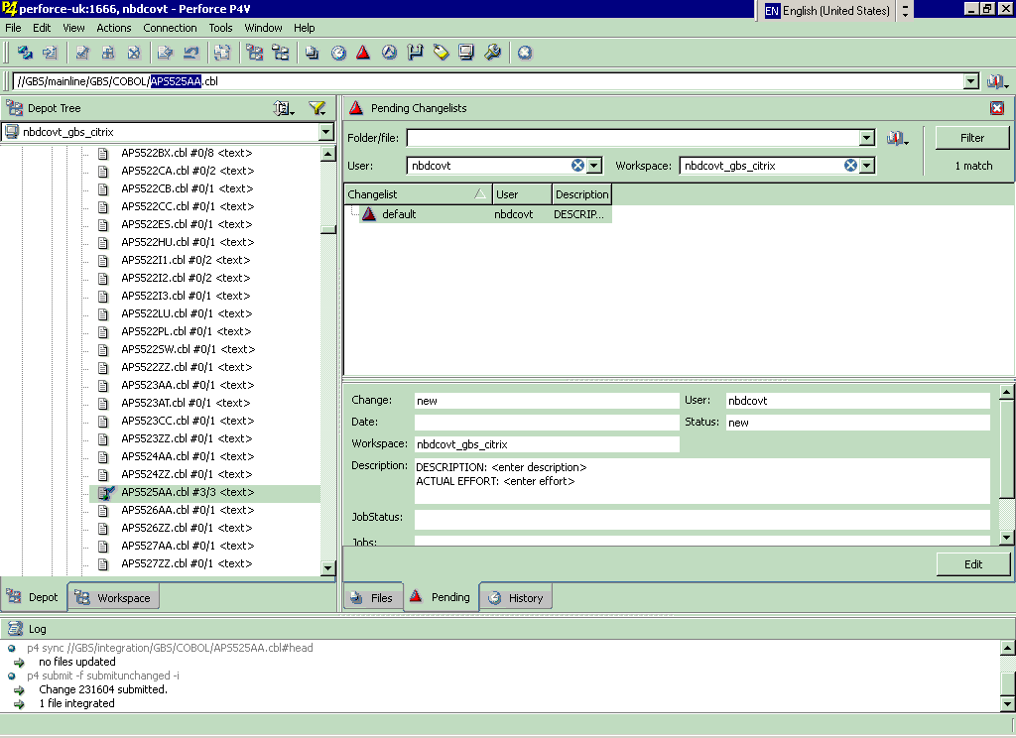

2) Check out as below

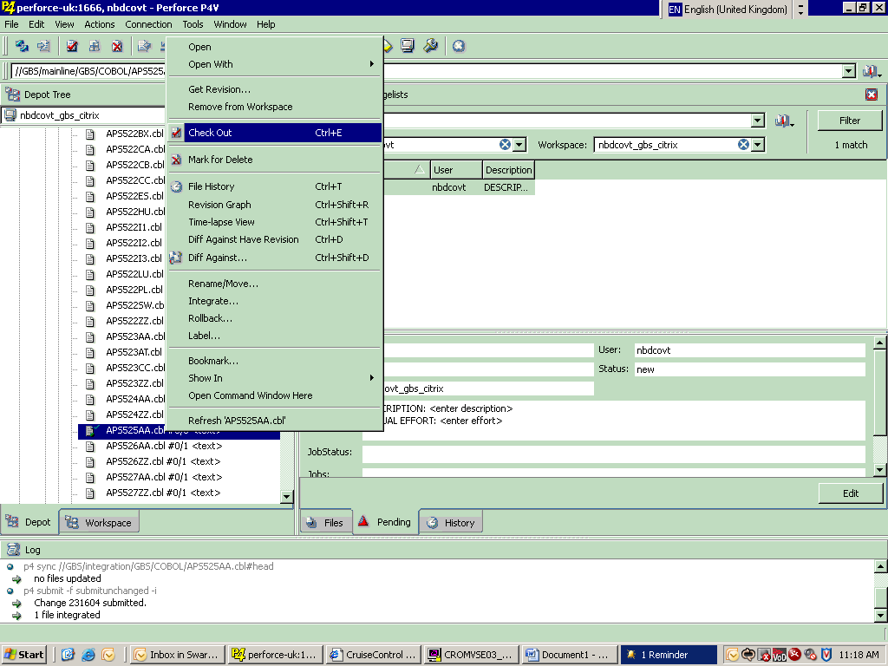

3) In MFE make the changes in RDC MFE and compile to make sure no errors exist.

4) On the Pending tab click “Submit…” option  
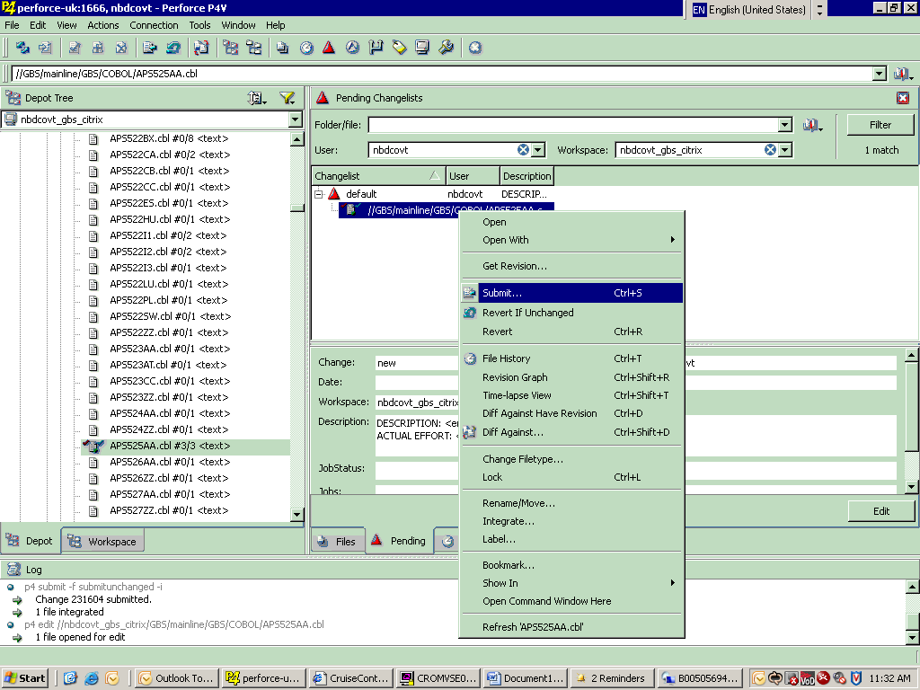

5) In the below screen provide “Write a changelist description” and “Job:” information. Click on the Add button to go to the screen 6).

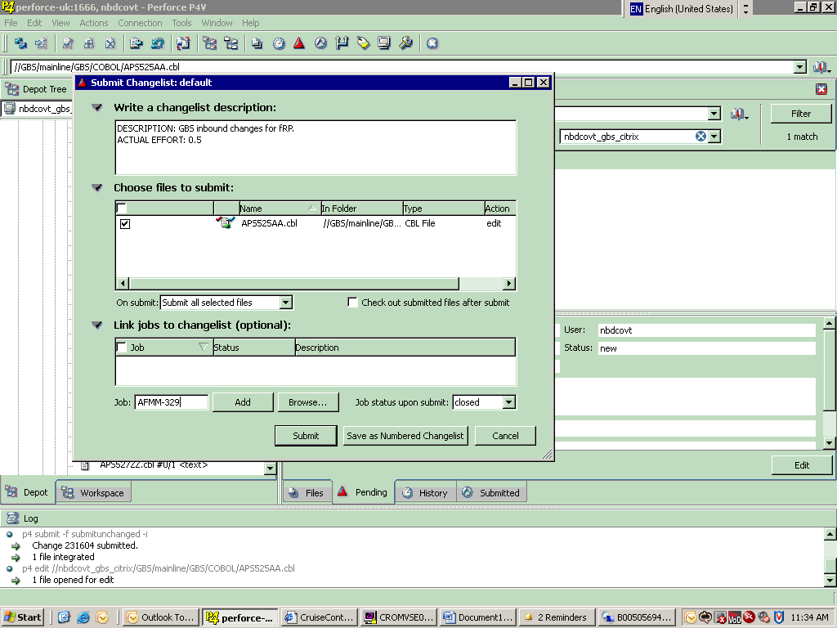

6) On the below screen click Submit button.

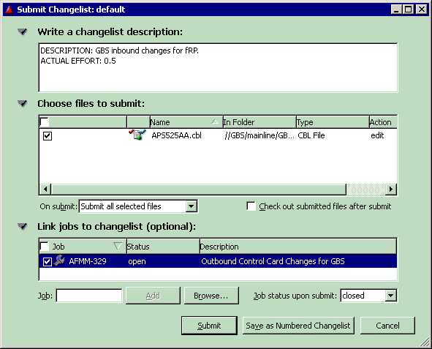

7) Go to Cruise Control <http://devlanman:8080/dashboard/tab/builds> and verify/force your program for build. An e-mail from CC DevLanMan Notification [joe.schmetzer@bankofamerica.com] with the subject [CC: **GBS-mainline** build.5013 Build Successful] is received as build completed successfully.  
Source will be placed in IBZLN1.MAINLINE.SORCELIB(APS525AA). Load is placed in IBZLN1.TESTP.APL01LIB  
In spool (=J.ST) [PRE PZB*] to see the submitted jobs.

8) Integration:

In the mainline directory right click on the component to select the “Integrate…” option.  
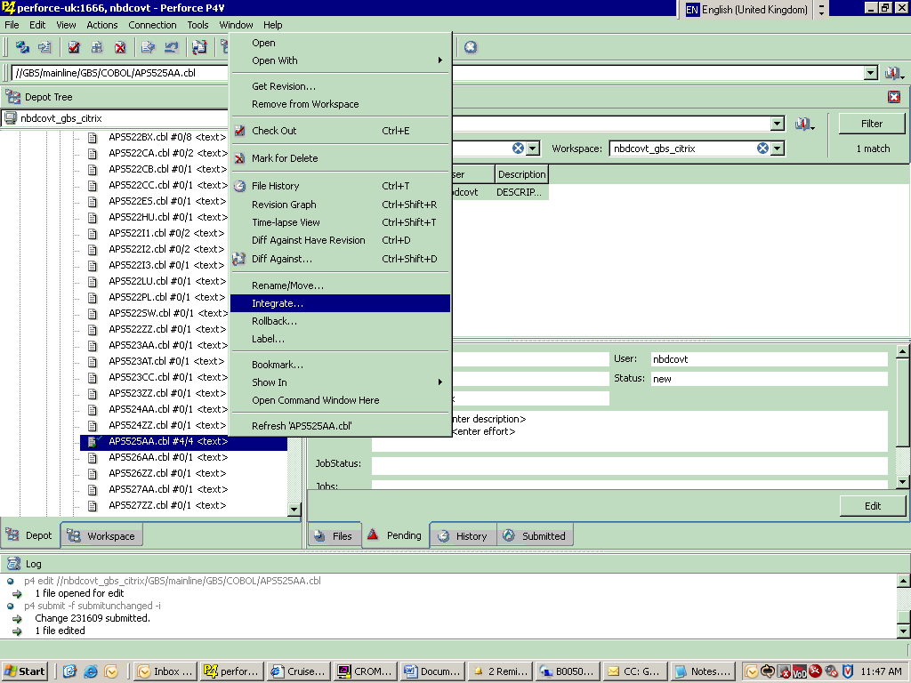

9) In “Choose target files/folders: “ change mainline to integration.  
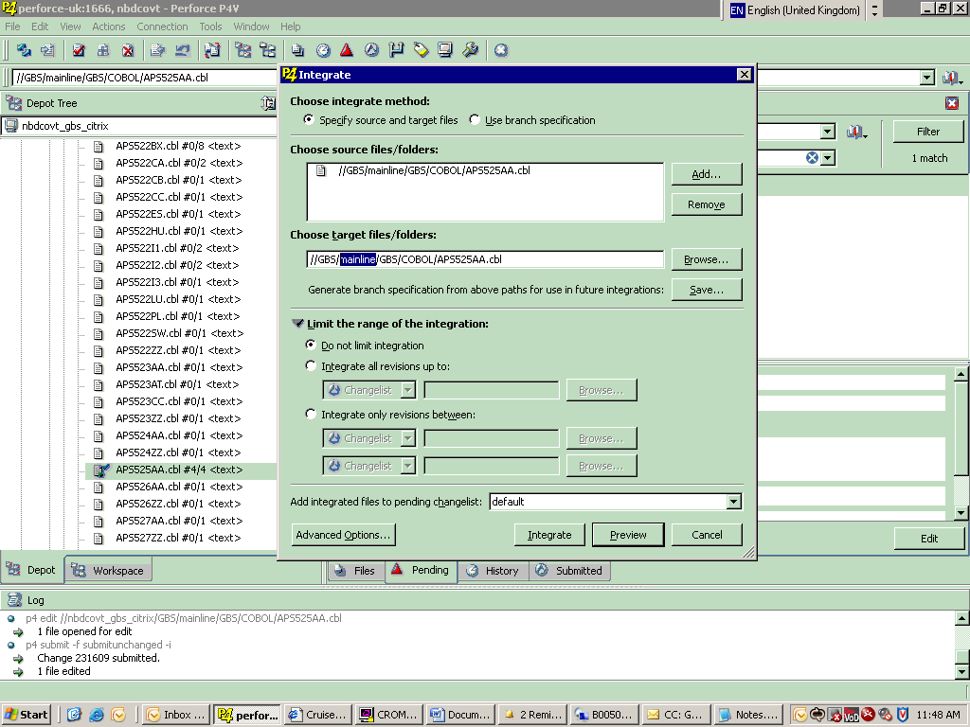

10) In the below screen observe “mainline” is changed to “integration”. Press on “Integrate” button.

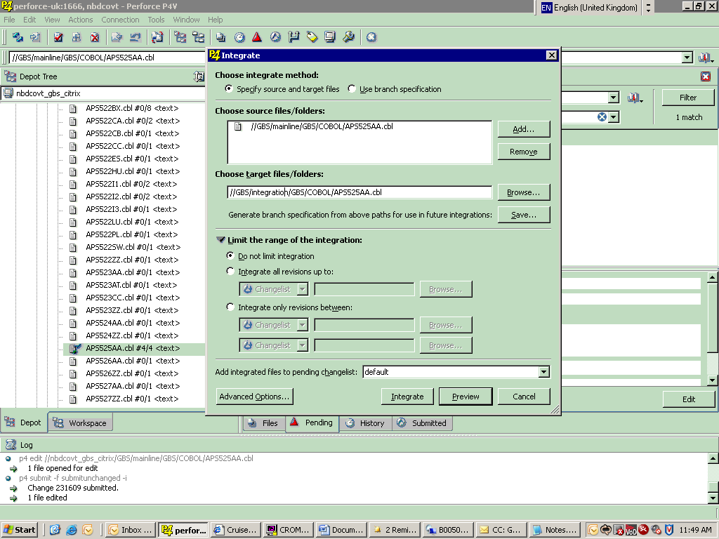

11) In the below screen, in pending tab, a question mark is seen on the member icon to resolve. Right click on the member and the select “Resolve…” option.  
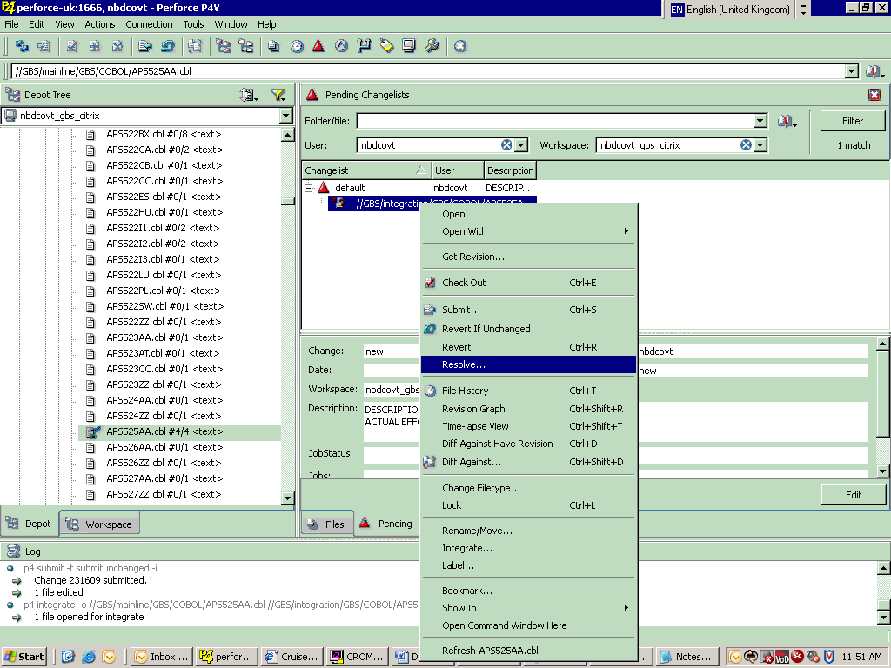

12) On the below screen click on the “Run Merge Tool” to see the changes as seen in screen 13).  
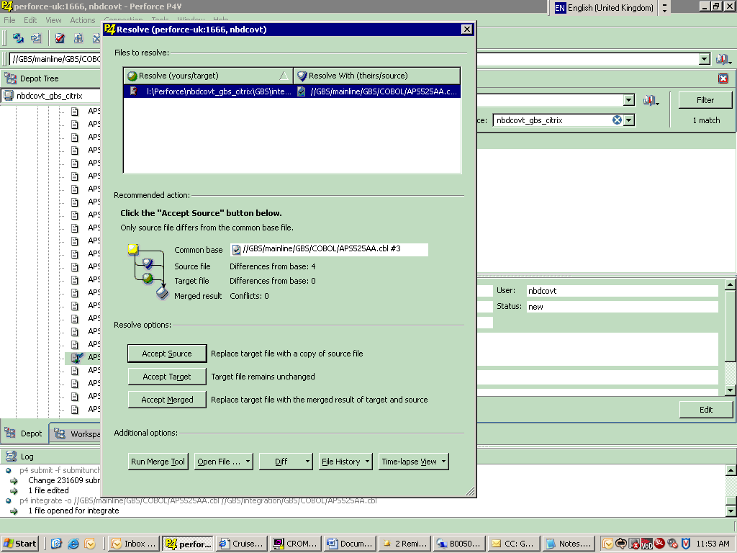

13) Close the below screen to get a prompt.  
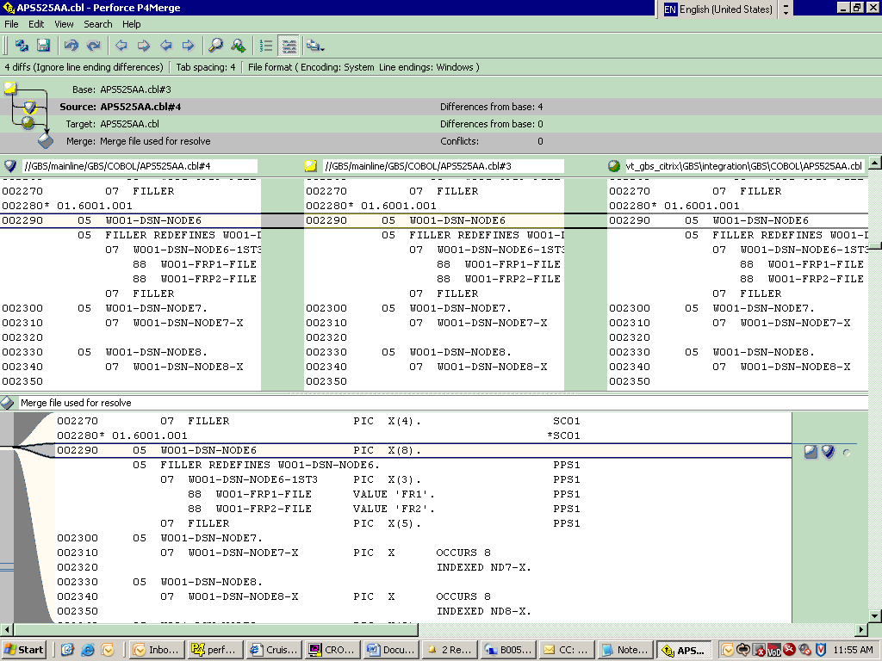

14) In the below screen press on “Yes” button to merge the changes.  
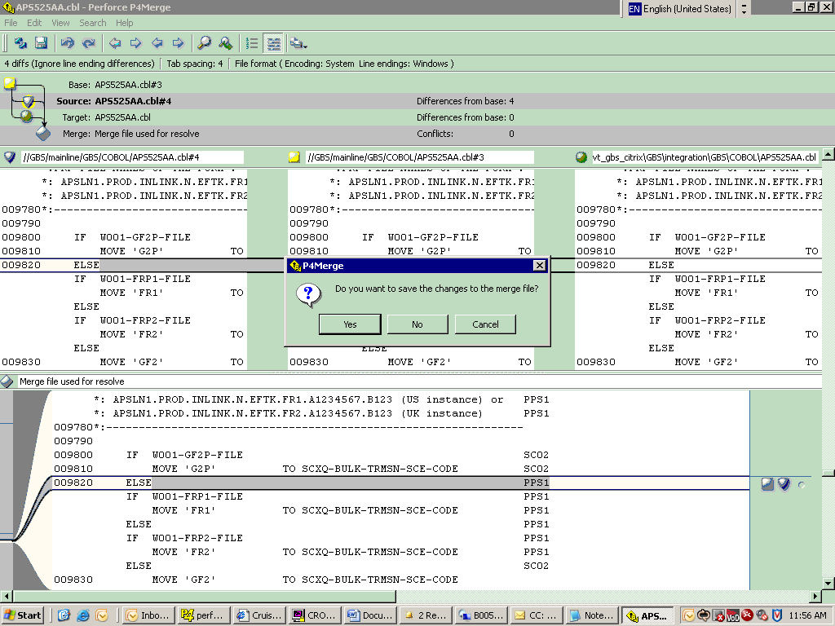

15) If component already exists in the Integration then a prompt will be display as below. Click on “Yes” button.  
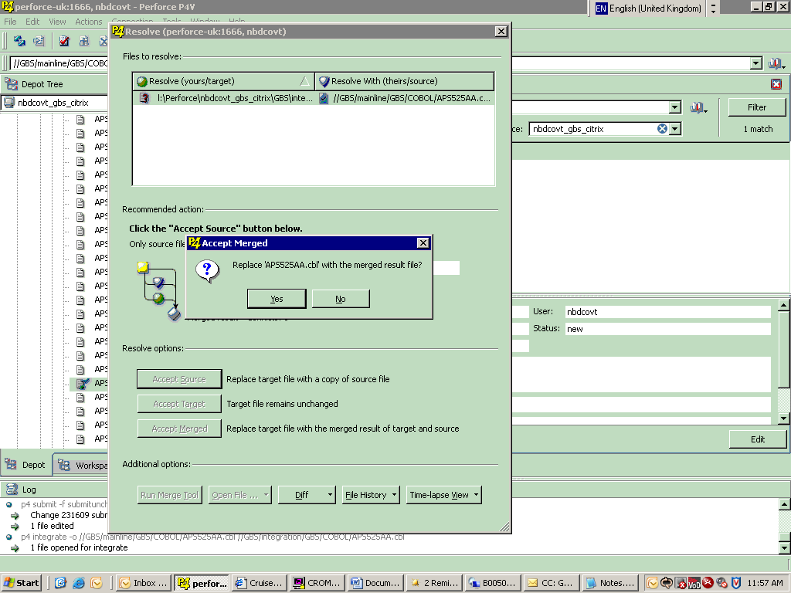

16) In the below screen on the “Pending” tab, right click on the member to “Submit…” for integration.  
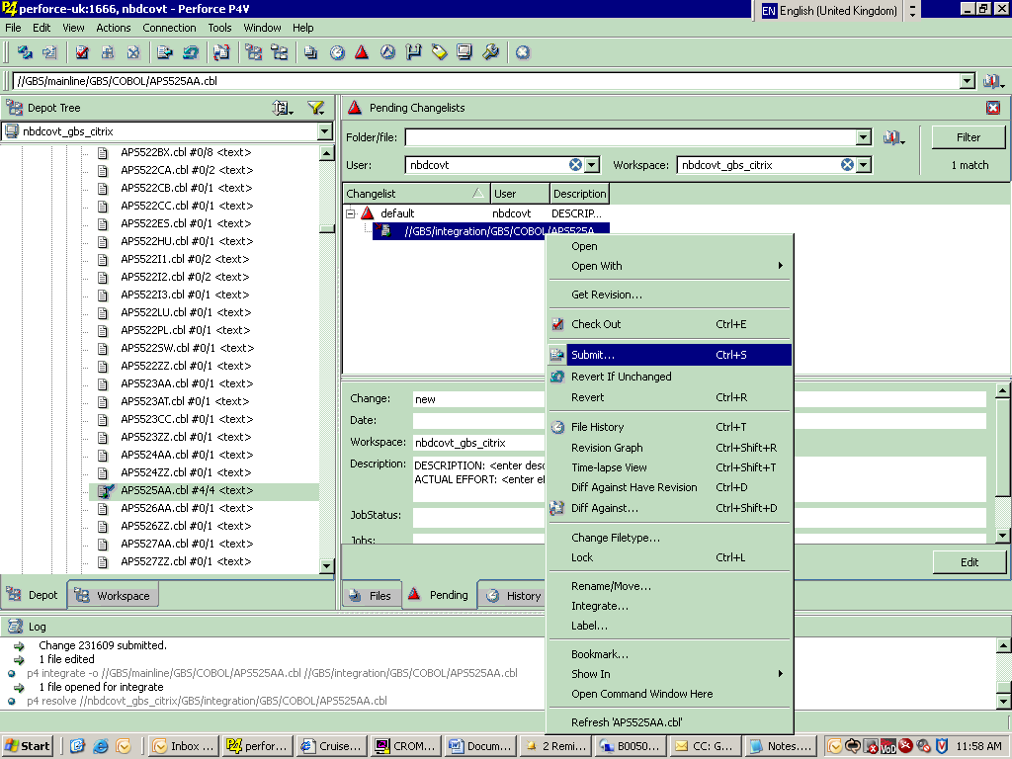

17) In the below screen provide “Write a changelist description” and “Job:” information. Click on the Add button to go to the screen 18).  
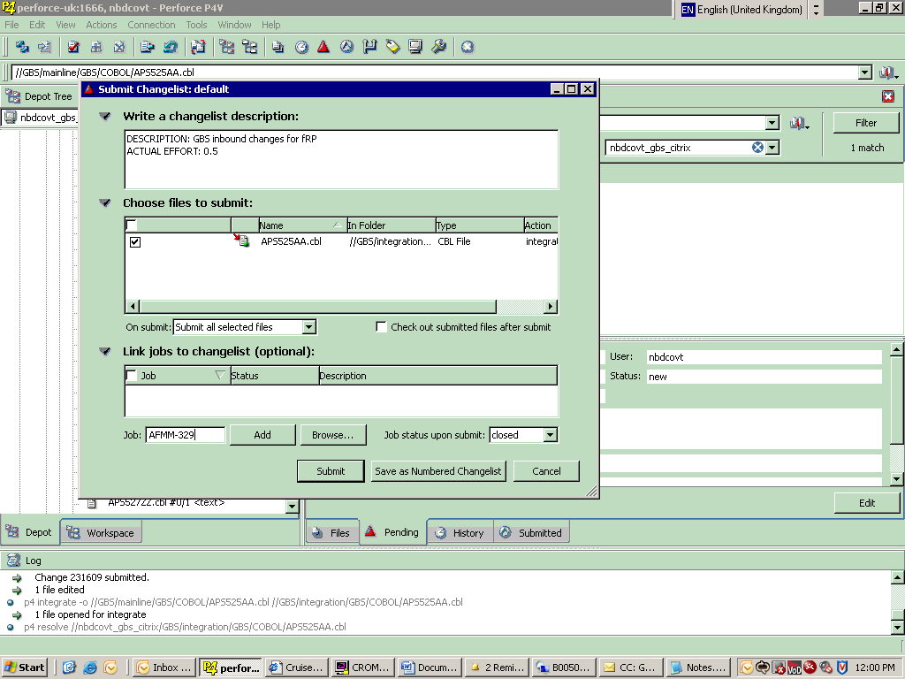

18) In the below screen click on “Submit” button.  
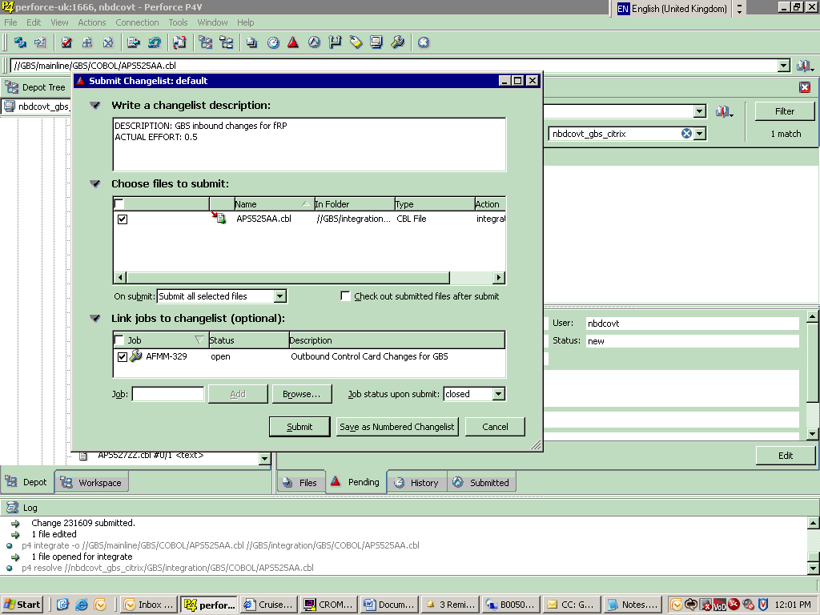

19) Below Zebra status shows that request is being processed. Go to Cruise Control <http://devlanman:8080/dashboard/tab/builds> and verify/force your program for integration. An e-mail from CC CC DevLanMan Notification [joe.schmetzer@bankofamerica.com] with the subject [CC: **GBS-integration** build.3713 Build Successful] is received as build completed successfully.  
Source will be placed in IBZLN1.TESTP.SORCELIB(APS525AA). Load is placed in IBZLN1.TESTP.APL01LIB  
In spool (=J.ST) [PRE PZB*] to see the submitted jobs.

